COVERING SHEET – INSTRUCTIONS

THIS COVERING SHEET MUST BE REMOVED BEFORE SENDING EASY READ QUESTIONNAIRE TO SERVICE USER.

The availability of the Easy Read questionnaire will be signposted on the mailing letters and multi-language sheet, and administered at the request of the service user.
Once requested, the following steps should be taken.

Administering the request:
- Any highlighted yellow text on this Easy Read booklet should be personalised. The booklet contains both the Easy Read cover letter and questionnaire.
- The booklet should be posted to the service user alongside a return envelope. You can either use the Freepost address you have set up or include a stamped addressed envelope to a different processing address.
- Please log any Easy Read requests in the fieldwork monitoring spreadsheet.
- We recommend that service users who request Easy Read questionnaires are logged as opt-out (outcome code 4). This will ensure they do not receive any further mailings. If the service user then takes part in the survey, the code should be changed to complete (outcome code 1). At the time of the service user requesting the Easy Read, if it is likely they will receive a further mailing (e.g. due to mailing deadlines) it is worth making them aware this will happen, but that an Easy Read will also be sent to them.
If the service user does not take part in the survey, the Easy Read request noted in the weekly monitoring spreadsheet should be left in and an outcome code 6 added.

Processing the return:
Manually enter responses into the Excel data entry spreadsheet for Easy Read questionnaire responses.




Survey number: | [INSERT HERE]


Please tell us about the care you receive from NHS community mental health services
2025

 | Easy read version of the Community Mental Health Survey 2025
 |  | About this booklet
 |  | We would like you to answer some questions about the care you receive from your community mental health team.
 |  | You might have seen someone from the community mental health team in person, on a video call, or on the telephone.
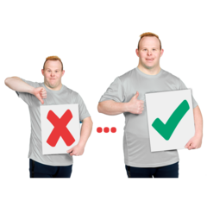 |  | Your answers will help improve community mental health services.
 |  | You can answer each question by putting a tick in the box next to the answer you want.
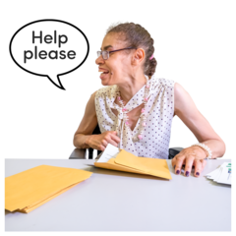 |  | You can ask somebody to help you read the questions and answer them if you want.
 |  | But they should not tell you which answer to pick, because we want to know what you think.
 |  | You do not have to answer all the questions if you do not want to.
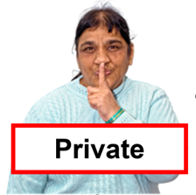 |  | Your answers are private. We will not use your name when we share what we have found out from all the answers we receive.

 | Your care and treatment
 | - Did your NHS mental health team listen to what you had to say?
 |  | ☐ Yes
 |  | ☐ Sometimes
 |  | ☐ Not at all
 |  | ☐ I do not know or cannot remember
 |  | - The last time you saw someone from the community mental health team, did they give you enough time to talk?
 |  | ☐ Yes
 |  | ☐ Sometimes
 |  | ☐ Not at all
 |  | ☐ I do not know or cannot remember
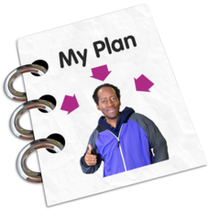 |  | - Did you feel the community mental health team gave you the right care and treatment?
 |  | ☐ Yes
 |  | ☐ Sometimes
 |  | ☐ Not at all
 |  | ☐ I do not know or cannot remember

 | - Did the community mental health team help you make decisions about your care?
 | ☐ Yes
 | ☐ Sometimes
 | ☐ Not at all
 | ☐ I do not know or cannot remember
  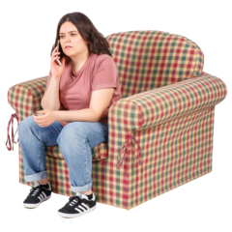  HELP! | - During your care and treatment, you might have needed help quickly. Were you able to get help when you needed it?
 | ☐ Yes
 | ☐ Sometimes
 | ☐ Not at all
 | ☐ I did not need this
 | ☐ I do not know or cannot remember
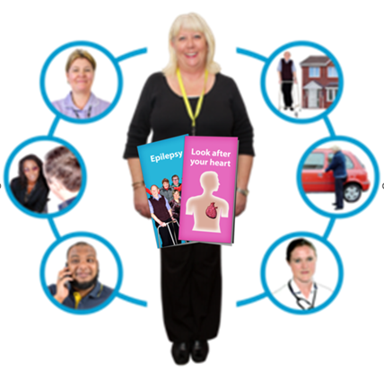 | - How good were the people you saw at supporting you with any physical health problems you might have?  A physical health problem might be an injury, disability, or condition like diabetes or epilepsy.
 | ☐ Good
 | ☐ OK
 | ☐ Bad
 | ☐ I did not need this
 | ☐ I do not know or cannot remember

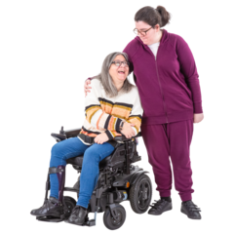 | - Did the people who provided your care and treatment include your family or someone else close to you as much as you would like?
 | ☐ Yes
 | ☐ Sometimes
 | ☐ No
 | ☐ I did not need this
 | ☐ I do not know or cannot remember
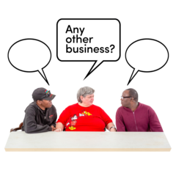 | General questions
 | - Did the people you saw treat you with respect?  Respect means that you accept somebody for who they are, even when they're different from you.
 | ☐ Yes
 | ☐ Sometimes
 | ☐ Not at all
 | ☐ I do not know or cannot remember
 | - How do you feel about the care you were given by the community mental health team?
 | ☐ Happy
 | ☐ OK
 | ☐ Unhappy
 | ☐ I do not know or cannot remember
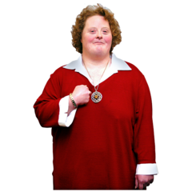 | About you
 | - How would you describe yourself?
 | ☐ Male
 | ☐ Female
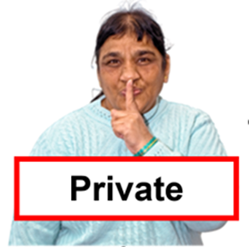 | ☐ I do not want to say
 | ☐ Other (please write down how you would describe yourself below)
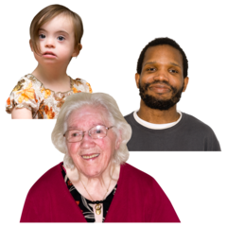 | - How old are you?  (Please write your age in years below.)
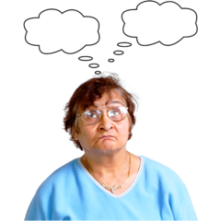 | Anything else
 | - Is there anything else you would like to tell us about your experience of using community mental health services?  Please write it below.
 | Thank you very much for answering these questions.
 | When we have looked at all the answers from everyone, we will write a report about what we found and put it on our website at: www.cqc.org.uk/surveys.
 | We will take out any information that could identify you before making your answers public. But the NHS trust and the people (like CQC) you send these answers to will see your full answers. If an answer needs looking into, we may share it with the best person to help.
 | What to do with your answers
   | Please post your answers back in the FREEPOST envelope provided. No stamp is needed.
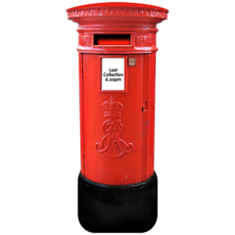 | If you do not have your FREEPOST envelope, please send your answers to <INSERT FREEPOST ADDRESS>

